A Three-Component Model of Student Engagement

Marcus G. Yeo
School of Instructor Education, Vancouver Community College
PIDP 3250: Student engagement
Jacquie Harrison
May 21, 2026

A Three-Component Model of Student Engagement

“Student engagement is a mental state that is the product of motivation and active learning.” (Barkley & Major, 2020)

Objective: Two-component models of student engagement group thinking and doing into the broad category of ‘active learning’, with the actual task, or ‘active learning technique’, being a support to reinforce theory. They dismiss the physical act of generation, and undervalue free reflection. A three-component model is proposed.

Reflective: Before researching the subject, I thought about what student engagement meant to me. Good engagement is enthusiastic participation and reflection. It’s seen in their posture, eye contact, and reaction time. I hear it in their answers, and identify it by their questions. They display engagement through physical output- be it a gesture, remark, or submission.
How I increase engagement is three-fold. First, I explain why it’s valuable (affective). Second, I talk about how we find success (cognitive). Then, I demonstrate it can be done, and they practice (psychomotor). Feel, Think, Do.
Barkley and Major (2020) presents a two-component model, where engagement is the product of motivation (affective) and active learning (cognitive), defined as “doing what we think and thinking about what we are doing.” (Bonwell & Eison, 1991). They argue that action has no effect on engagement, as engagement is a mental state. They place over-emphasis on the motivational component, referring to it as “the portal to engagement.” (Barkley & Major, 2020), and by combining knowledge and action into active learning, leave no room for free, or unassigned, reflection. This type of reflection occurs after active learning, and is unencumbered by the confines of reality. Just as action is bound to the laws of physics. Neither are represented.

Interpretive: Even if taken as fact, and engagement is only a mental state, then studies showing physical activity’s ability to increase cognitive functioning (Mualem et al., 2018) indicate the existence of a psychomotor lever capable of influence.
Adding a social component, Taylor and Marienau (2016) looked at the collected works of Brookfield, Fahim, and Wilbur, concluding “brief venture into the unknown will trigger mildly increased adrenaline or cortisol production, which can enhance learning.” Simply getting up and moving in a social setting can improve engagement. More evidence of a psychomotor component.
The pandemic of 2019 afforded an opportunity to compare the engagement of online versus in-person delivery. A study by Raes (2021) “did not find any significant differences between physical and remote presence regarding conceptual understanding, yet significant differences were found in regard of affective engagement in favour of the on-site students and remote students having the opportunity to interact.” Here mere physical presence is seen to improve engagement.
Fredricks et al. (2004) come close with a three-component model comprised of cognitive, emotional, and behavioural engagement, but miss in the same way as Barkley and Major’s assertation that “the physical act of learning behaviours” is not a “separate factor or type of engagement.” (2020). It’s not about learning or demonstrating behaviours, it’s about experiencing the process of generation via the human interface. Typing each letter of each word in an essay, or cutting and shaping each piece of wood for a chair. This desirable difficulty (Bjork, 1994) makes the work tangible and personal. It improves engagement by feeding a sense of self-worth, showing progress, and proving theory.

Decisional: Student engagement has three components; motivation (affective), reflection (cognitive), and action (psychomotor). Expressed as an intensity on a scale of zero to five, and depicted as spheres of influence, the components equally overlapped produce realms of engagement.
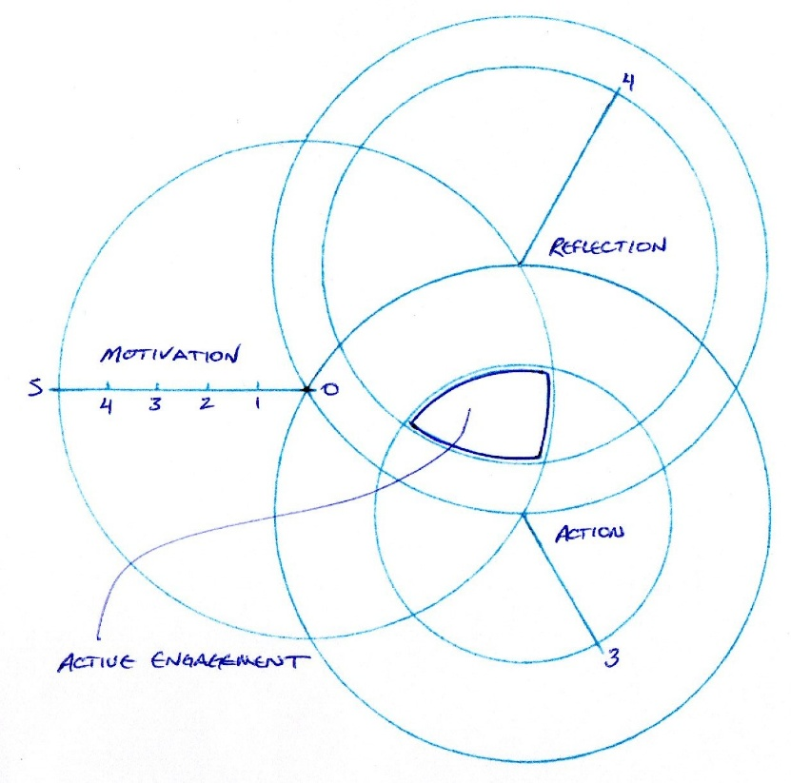
The Variable Component Contribution (VCC) model overcomes the argument against a traditional Venn diagram, only expressing overlap, by introducing intensities of influence. A departure from the Fredricks et al. (2004) wheel of engagement, and the double helix of Barkley and Major (2020), this three-component model affords greater accuracy in plotting level and predominant types of engagement.

Levels of influence:
Motivation Reflection Action
0 Apathy 0 Ignorance 0 Still
1 Concern 1 Awareness 1 Active
2 Inclination 2 Understanding 2 Proficient
3 Investment 3 Selection 3 Skilled
4 Passion 4 Deconstruction 4 Masterful
5 Zeal 5 Invention 5 Flowing

Types of Engagement:
Active Engagement is the combined forces of motivation, reflection, and action. It is where learning occurs.
Passive Engagement lacks at least one component, and doesn’t contribute to learning.
- Automated Engagement is motivated action without reflection.
- Philosophical Engagement is motivated reflection, but no action.
- Practical Engagement is action and reflection, without motivation.

Calculating Engagement:
Product of all components present.
Percentage of total potential area.

References

Barkley, E.F. & Major, C.H. (2020). Student engagement techniques: A handbook for college faculty (2nd ed.). New York: Wiley Jossey-Bass.
Bjork, R. A. (1994). Memory and metamemory considerations in the training of human beings. In J. Metcalfe & A. Shimamura (Eds.), Metacognition: Knowing about knowing (pp. 185–205). MIT Press.
Bonwell, C. C., & Eison, J.A. (1991) Active learning: Creating excitement in the classroom. Washington, DC: School of Education and Human Development, George Washington University.
Fredericks, J. A., Blumenfeld, P.C., & Paris, A. H. (2004). School engagement: Potential of the concept, state of the evidence. Review of Educational Research, 74(1), 59-109.
Mualem, R., Leisman, G., Zbedat, Y., Ganem, S., Mualem, O., Amaria, M., Kozle, A., Khayat-Moughrabi, S., & Ornai, A. (2018). The Effect of Movement on Cognitive Performance. Frontiers in public health, 6, 100. https://doi.org/10.3389/fpubh.2018.00100
Taylor, K., & Marienau, C. (2016). Facilitating learning with the adult brain in mind: A conceptual and practical guide. Jossey-Bass.
Raes, A. (2021). Exploring Student and Teacher Experiences in Hybrid Learning Environments: Does Presence Matter? Postdigital Science and Education. 4. 138-159. 10.1007/s42438-021-00274-0.

Intellectual Disclosure: No generative AI was used in the creation of this document.

